**SpeakEZ**

**AI Language Translator**



**Deployment and Installation Manual**

# Table of Contents

**Table of Contents 2**

**Introduction 2**

**System Requirements 2**

Hardware requirements 2

Software requirements 3

**Installing Procedures 3**

Download Python 4

Downloading Node.js and npm 4

**Cloning from the Git repository 5**

**Installing other dependencies 6**

**Firebase 8**

**Server Deployment 9**

**Guidelines on naming convention and coding standards 9**

**Instructions on testing 9**

**Reach out to us! 10**

# Introduction

SpeakEz is an AI integrated web application that allows users to transcribe and translate the contents of MP3 files into different languages, bridging the gap between international languages around the world. The application uses HTML, CSS, JavaScript and React for the frontend functionalities of the website and Python for the server backend. To integrate these programming languages, our project uses Visual Studio Code as the IDE. We are also using libraries such as Vite to build the project faster, HuggingFace to provide trained AI models and datasets, and MaterialUI and Tailwind CSS to provide a modern user interface. The application is version-controlled using GitHub for the open-source community.

# System Requirements

## Hardware requirements

Requires a 64-bit processor and operating system. SSD is highly recommended.

* Processor (CPU):
  + Minimum:intel i3-6100 equivalent
  + Recommended: Intel Core i5 750 or higher
* Memory (RAM): 8GB RAM
* Available Storage on Disc:4GB available space
* GPU: Geforce GTX 670 / Radeon HD 7970 or AMD series

## Software requirements

* Operating System for Desktop Recommended
  + Windows 10 64 bit or higher
* OS for Mobile
  + Android or iOS

# Installing Procedures

* Installing VS code
  + Download the VS code from <https://code.visualstudio.com/> and follow the on-screen instructions to set up the VS code on your local PC
  + To familiarize with the framework follow the documentation on their website - <https://code.visualstudio.com/docs>
* Once Visual Studio Code is set up, clone the application’s Git Repository
* There are multiple ways of cloning the git repository in your local computer

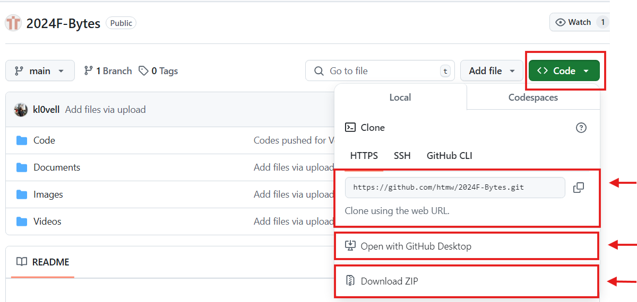

* One can simply “Download ZIP” and download the whole application in a ZIP folder allowing to have a local copy of the project
* For users comfortable using GitHub Desktop, you can click on the “Open with GitHub Desktop” button
* Or, you can use the web URL in the visual studio code terminal

## Download Python

* Download python from <https://www.python.org/downloads/windows/>
* Make sure **not** to exceed **version 3.12**
* In the cmd make sure to check the version by running “*--version*”
* Once python is downloaded, make sure that the python path is in the environment variable

To add the python path in the environment variable, follow the steps below:

* Search “edit the system environment variables” in the search window. If you cannot find it, go to *Control Panel -> System -> edit environment variables* for your account
* Once clicked, it should open a System Properties dialogue box, click on “environment variables” on the right bottom to open another dialogue box “Environment Variables” in the first box, click on the “Path” where the “edit environment variable” dialogue box will open. Edit and add the python path in there. Make sure to move up that path at the very top in the list. You can refer to the image below.

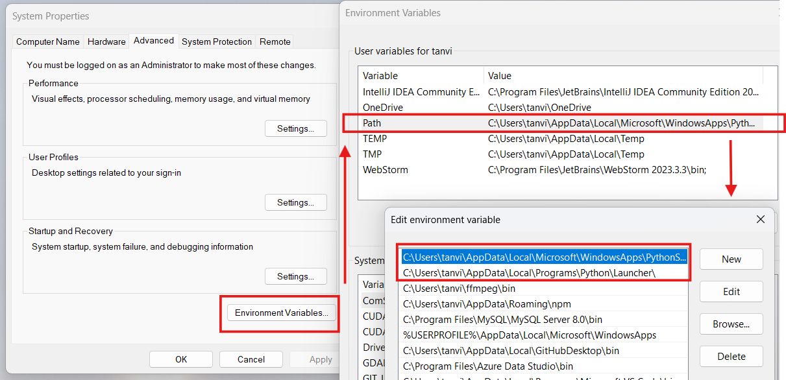

* In case, you download the modern version of the python. Go to “Control Panel” in your windows search, and click on “uninstall a program”. Find “python launcher” and “python version-number (64-bit)” and right click on them. You will see an option of “uninstall”. This should delete all the unwanted python-version with all its sub files.

## Downloading Node.js and npm

* Download node.js from <https://nodejs.org/en/download>
* Recommended to install version 20.11.1 or more. The LTS version is for stability.
* Once the installer is downloaded, follow the wizard instructions. For guidance, follow <https://nodejs.org/en/learn/getting-started/how-to-install-nodejs>
* Once downloaded, open cmd in the windows search and run, “node -v” and “npm -v” command line. These will show current versions installed in your system.

# Cloning from the Git repository

* Open Visual Studio Code, click on the “Clone Git Repository” button.
* It should open the “Provide repository URL or pick a repository source” placeholder, where you can paste the web URL copied from GitHub (<https://github.com/htmw/2024F-Bytes.git>)



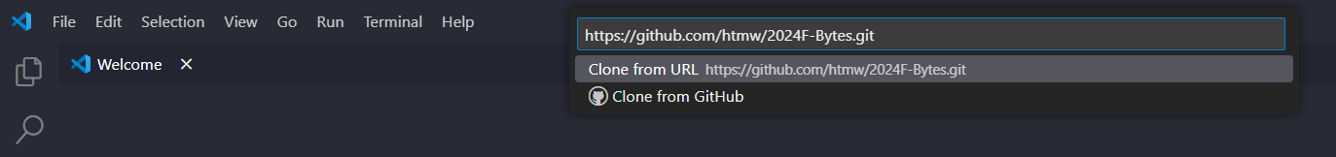

* Click on the “Clone from URL” button which will open File Folder. Select your Repository Destination, where you want the project to be in your local laptop.
* You can also run the command in the vs code terminal “*git clone https://github.com/htmw/2024F-Bytes.git*”

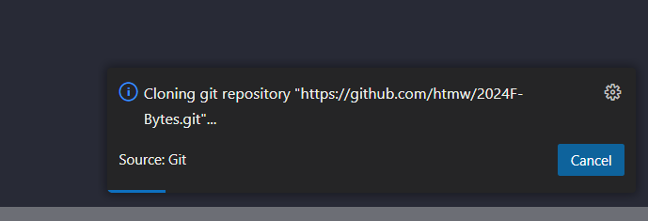

* The above bar will be displayed in your vs code, showcasing the cloning from the git repository.
* Open the cloned repository, and you should be able to see folders inside the application’s git repository.

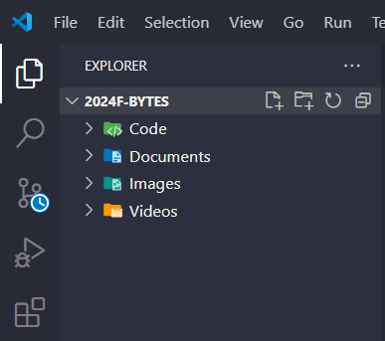

# Installing other dependencies

Open a new terminal under Terminal header or press “Ctrl + Shift +” inside VS Code.

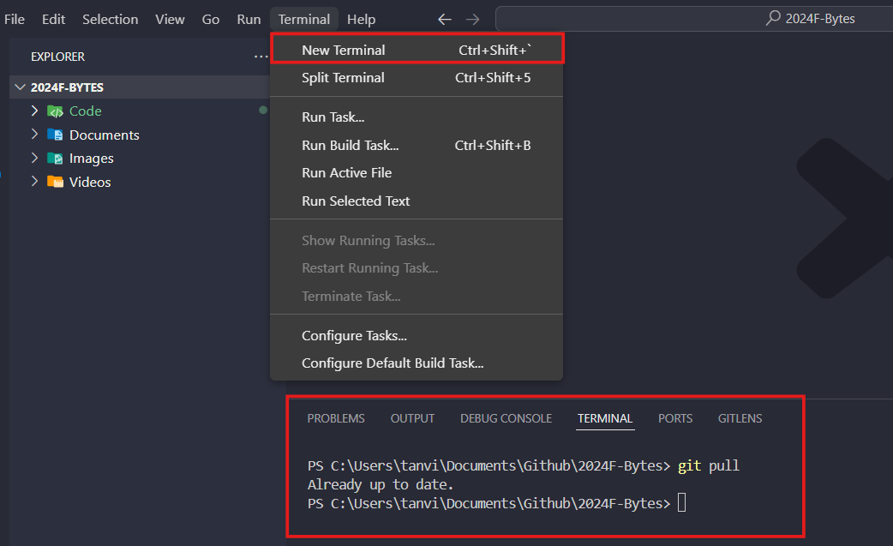

Before running the application make sure to run “*git pull*” to make sure you have pulled the latest changes

Then, write the following commands

* pip3 install openai-whisper
* pip3 install librosa

In case issues arise depending on the OS and system requirements, try the following commands,

* pip3 install wheel
* pip3 show wheel
* pip3 install pydub
* python -m pip install --upgrade pip setuptools wheel

You can also check the required packages needed, by navigating to *Code -> server -> requirements.txt*, and install dependencies manually in the terminal.

Once the dependencies are installed, navigate to the server folder

* cd code
* cd server
* npm install or npm update
* node app.js

Now the server should be running, let the server keep running, and create a new PowerShell in the VS terminal as shown in the gif below:



Then type the following commands in the new powershell terminal.

* cd code
* cd speakez
* npm i vite (if vulnerabilities exist, run the command “*npm audit fix*”)
* npm run dev
* Click on the local host link from the npm run dev

# Firebase

* We use Firebase to store the user data in the database
* Login to the firebase at <https://console.firebase.google.com/> and create an account or use your existing account.
* Select “Add Project” and enter your project name. Follow the Firebase instructions.
* Now, go to *firebase console -> project overview -> project settings*.
* Scroll down to the app section. If you do not see your app, create a new app.
* You can locate your config file. This config file will connect the database to the application.
* You can copy or add that config file to your server code as “config.js” or deploy the config file to the Google Cloud Platform for the server (reminder: do not push this file to the GitHub, as it has credentials on it)

# Server Deployment

* Install Google Cloud CLI and Google Cloud SDK
* Create an app.yaml file mentioning the system specifications (include runtime, env, entrypoint, runtime_config, env_variables and resources). This depends on each local desktop, for more information follow <https://cloud.google.com/appengine/docs/standard/reference/app-yaml>
* Create requirements.txt, including all the python packages
* Create a startup.sh file, the google cloud platform will automatically detect this file and run this file first, we can also include this ./startup.sh in the package.json just to be sure. This file includes code to install pip and python and also includes the code for installing all the required packages and runs the "node app.js" after installing all the required packages. For more guidance, follow, <https://cloud.google.com/deploy/docs>

# Guidelines on naming convention and coding standards

Some basic coding conventions for our project:

* Use camelCase for variables and functions
* Use PascalCase for class names
* Use indentation/whitespace within code blocks
* Use braces for code structures (if, for, while)
* Use single-line(//) or multi-line(/*...*/) comments to explain the code
* Write a brief explanation before committing to the merge branch
* Above all else, stick to a consistent code style

# Instructions on testing

* Test the code before merging it to the main branch
* Add test cases, explaining how they were carried out

# Reach out to us!

If you have more questions or concerns regarding our application, feel free to reach out to us:

[speakez-bytes@googlegroups.com](mailto:speakez-bytes@googlegroups.com)